Table . Univariate OLS regression statistics for species richness.

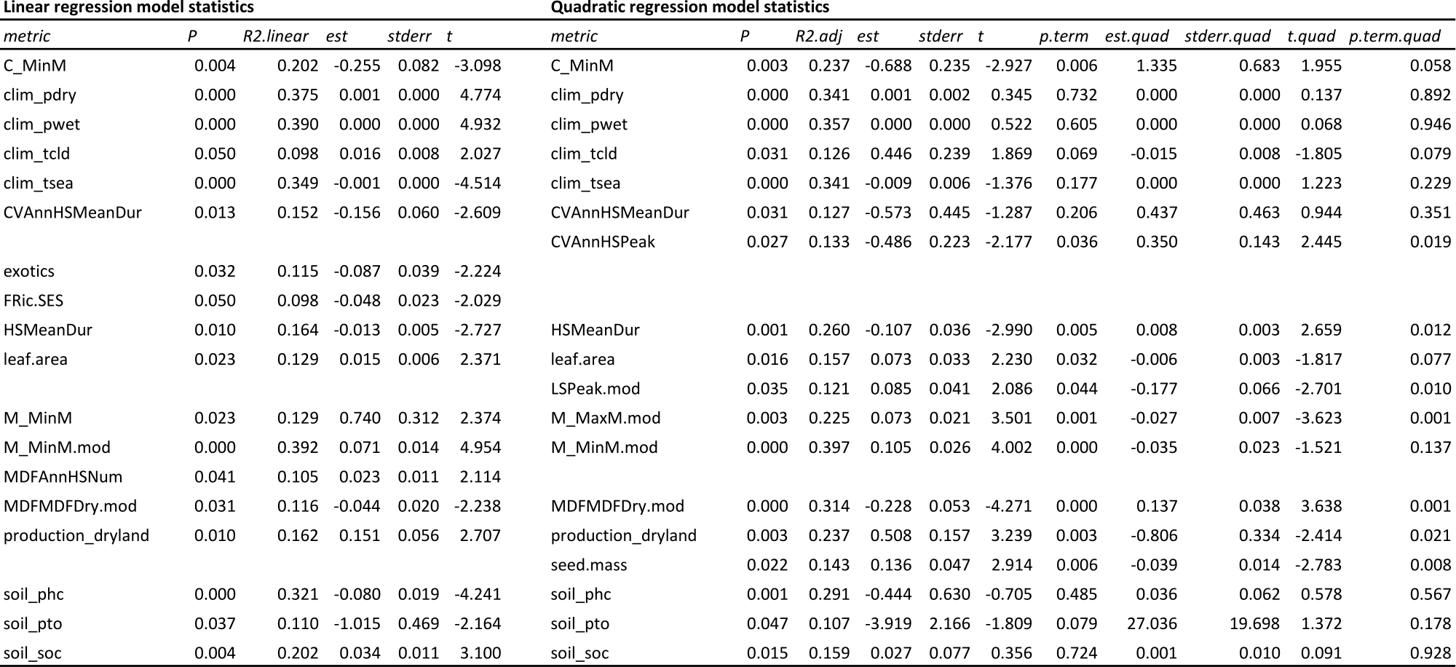

Table . Univariate OLS regression statistics for FRic.SES.

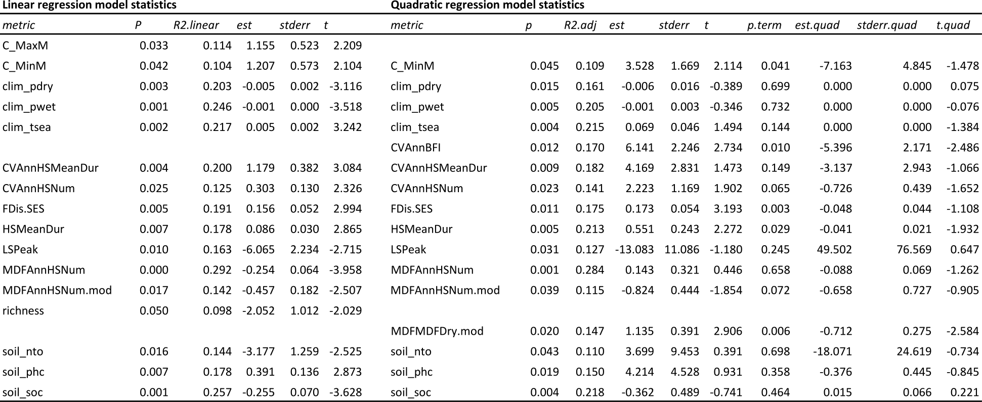

Table . Univariate OLS regression statistics for FDis.SES.

